DUOC UC — Computer Science and Telecommunications
PTY4614 — Capstone / Degree Portfolio
Phase 2 — APT Project Development

2.4 APT Project Development Guide

Project name | Kill Bichos IA — AI-assisted visit scheduling and geospatial trap mapping
Students | Javier Lara Bustos / Pedro Vergiu / Juan Bórquez
Campus | DUOC UC — Viña del Mar
Repository | github.com/j4vierlb/PROYECTO-TESIS-
Report date | October 22, 2026

Table of contents
Abstract 3
1. Project progress summary 4
2. Work plan monitoring 8
3. Adjustments based on monitoring 10
3.1 Plan for the remaining weeks 11
3.2 Contribution of each team member 11
4. Appendices: technical evidence of progress 13
4.1 Data model (PostgreSQL + PostGIS) 13
4.2 FastAPI backend (Swagger / OpenAPI) 14
4.3 Mobile app (Flutter) 14
4.4 Web panel (React) 15
4.5 Running database (Docker) 16
4.6 Test results 16
4.7 Version control (GitHub) 18
4.8 Repository structure and traceability with Git 19
4.9 Google Maps API keys 20
4.10 Real WhatsApp test from a phone 21
5. Conclusions and reflection 22
6. References 22

Abstract
This report presents the progress of Phase 2 of the Kill Bichos IA project, a system that automates visit scheduling and trap mapping for a pest control company in Macul, Chile. Four connected components are already built: a PostgreSQL database with PostGIS, a FastAPI backend with 25 endpoints, a React web panel for the administrator and a Flutter mobile app for the field technician. Two artificial intelligence features are also integrated: a WhatsApp agent that schedules visits and an AI that suggests trap locations from a satellite photo, which the technician then confirms. The whole system (database, backend and panel) starts with a single Docker command. The mobile app keeps the session when reopened and lets the technician build the trap map in the field with Google Maps and reference photos, and the panel shows that map in read-only mode. We ran a test matrix of 50 cases: the automated integration script passed 32 of 32 cases in its latest run (October 21), and the automated tests of the backend (107), the web panel (98) and the mobile app (18) also passed. All the work was merged through 19 reviewed and merged Pull Requests (numbered up to #20), with no direct commits to the main branch. A real WhatsApp test from a phone, using a paid Twilio account, passed 8 of 9 cases. Still pending are the remaining case, testing the trap suggestion with real addresses, Android testing and offline mode.
Keywords: pest control, FastAPI, PostGIS, Flutter, WhatsApp, artificial intelligence.

1. Project progress summary
APT project progress summary
During the first weeks of Phase 2, Juan Bórquez gathered the requirements with the client (a pest control company), an activity that was completed without problems. In parallel, Javier Lara Bustos designed and deployed the relational and geospatial database (PostgreSQL + PostGIS) in a Docker container, with 9 tables and test data. Two helper scripts were also added for demonstrations: reset_demo.sql, which restores the day's visit to its initial state, and demo_historial.sql, which loads past completed visits with their trap maps.
Javier Lara Bustos built the backend in FastAPI (a component that, within the "Web panel + scheduling" activity, was originally assigned to Juan Bórquez). The backend provides login with an 8-hour JWT token and a 30-day refresh token, the technician's daily agenda, a paginated history of completed visits, visit details and editing, trap map queries, and trap management (confirm, move or remove). Passwords are stored hashed with bcrypt, each technician can only access their own visits, and coordinates are handled with PostGIS. The API has 25 endpoints in total.
Javier Lara Bustos also developed the operator's mobile app in Flutter, ahead of the original schedule (weeks 9-10). The app lets the technician sign in, review the day's agenda and the history, start and complete visits, record notes, and confirm or remove traps on the trap map; completed visits become read-only. It uses the company's visual identity, stores the tokens encrypted on the phone, and was tested on a real iPhone connected to the backend over WiFi. It was merged into the main branch through Pull Request #2.
Juan Bórquez developed the web panel in React, merged into the main branch through Pull Request #4. The panel lets the administrator sign in, view statistics, schedule visits by date and assign them to technicians, and manage clients. To support it, Juan added 10 administration endpoints for clients and visits to the backend, with different permissions for technicians and administrators; each administrator only sees their own company's data. As business rules, deleting a visit marks it as cancelled, and clients with associated visits cannot be deleted.
Because of the uneven availability of team members in the middle weeks of the phase, the team reassigned the WhatsApp conversational agent to Pedro Vergiu. Pedro implemented the WhatsApp integration using Twilio and OpenAI, with its database migration (migracion_message_sid.sql): the client writes on WhatsApp, the AI interprets the message, and the backend validates the date, business hours and technician availability before creating the visit. It includes Twilio signature validation, discarding of repeated messages, and a fallback reply if anything fails. The module was merged through Pull Request #5.
With the five parts integrated, Javier Lara Bustos coordinated a series of fixes, each in its own Pull Request and tested before merging. PR #6 allows clients without an address or coordinates (such as those arriving through WhatsApp), which previously caused errors. PR #7 calculates "today" using Chile's local time, since after 9 p.m. the agenda showed the next day's visits. PR #8 lets the database, backend and web panel start with a single command (docker compose up --build). PR #9, by Juan Bórquez, applies the same date fix in the panel. PR #10 fixes a 500 error when creating a visit without an assigned technician. PR #11, also by Juan Bórquez, fixes the three pending web panel issues (times shown in Chile's local time, the Clients screen with clients without coordinates, and the "Unassigned" option), with automated tests and browser verification against a real PostgreSQL/PostGIS database (report pruebas/Panel_regresion_2026-10-09.md).
Between October 17 and 20, four more Pull Requests were merged. PR #12, by Pedro Vergiu, adds the plan for the real WhatsApp test, the cost estimate of the agent's AI (between 0.3 and 0.5 Chilean pesos per message on OpenAI, not including Twilio) and the design of the AI trap map. PR #13, by Javier Lara Bustos, allows creating the trap map in the field, adding traps by GPS or by tapping the map, and taking a reference photo of each one, with its database migration and a 32-case regression that fully passed. PR #14 isolates visits and trap maps by company, so that an administrator cannot see or modify another company's data. PR #15 keeps the app session when it is reopened and adds the POST /auth/refresh endpoint, which renews the token without asking for the password.
Between October 21 and 22, five more Pull Requests were merged. PR #16, by Juan Bórquez, completes the web panel with the trap map viewer (map, traps and private photos, read-only), with its tests and evidence, and updates the management documents. PR #17, by Pedro Vergiu, implements the AI trap map, which suggests trap locations from a satellite photo of the property, with the "Suggest with AI" button in the app; it geocodes the address of WhatsApp clients; makes the backend validate the schedule and offer an alternative; and adds a bridge that allows testing WhatsApp with a Twilio Trial account. PR #18 fixes the regression script so that it schedules within business hours and works at any time (32 of 32 on Wednesday the 21st at 23:04). PR #19 reorganizes Phase 2 according to the delivery structure. PR #20, by Pedro Vergiu, records the real WhatsApp test from the phone with the Twilio account already upgraded: according to the repository record (docs/HU-18_prueba_whatsapp_real.md), the agent answered on the phone in 8 of the 9 planned cases.
Testing
A matrix of 50 test cases was designed, identified as PU (unit), PI (integration), PS (security) and PR (performance), and a script (pruebas/ejecutar_pruebas.py) was written to run the integration cases against the system running in Docker. On October 6, the first run produced 29 passing and 3 failing cases (PI-17, PS-12 and PR-03); the causes were a real backend bug (a visit's response schema required a technician even though the database allows visits without one) and Twilio configuration variables missing from the test environment. After fixing it (PR #10), the second run passed all 32 cases, and the regression was repeated with the later changes (field trap map, isolation by company and persistent session): the latest run, on October 21 (23:04), passed 32 of 32.
In addition, in the October 20 run the 107 automated backend tests (which include 30 company-isolation cases), the 98 web panel tests and the 18 mobile app tests passed. After PR #16 and #17 the team reports more backend tests (156), whose execution report is still to be archived in the repository. The real WhatsApp test from the phone (October 22) passed 8 of 9 cases according to the repository record; case 8 (the agent without the OpenAI key) and the screenshots of case 3 remain.
In PR #11, Juan Bórquez added a panel regression suite of 51 automated tests (29 frontend and 22 backend: 11 integration tests against a real PostgreSQL/PostGIS database and 11 HTTP contract and date tests), with screenshots of the browser verification. In the matrix, 45 of the 50 cases passed with evidence, 3 were verified manually, 1 by code review, and 1 is pending. In the performance test, the 95th percentile of response times was between 0.08 and 0.29 s.
Objectives
Not applicable — the general and specific objectives defined in Phase 1 are kept without changes.
Methodology
The agile methodology based on Scrum (Schwaber & Sutherland, 2020) defined in Phase 1 is kept, with two adjustments in its execution. First, the specific reassignment of owners for certain activities (detailed in section 3). Second, the real iterations were not weekly: they had irregular lengths, and the mobile app was moved forward because the backend already provided the data it needed. That order was documented in the Sprint Backlog and the Sprint Sheets, reconstructed from the Git history, and from October 5 onward weekly sprints are fixed. In addition, the sprint plan (document 02) and the sheets (document 04) were compared against the Git history: section 4.8 shows which Pull Requests back each sprint and which part of the plan still has no evidence.
Tools and technical environment
Phase 1 established the use of a relational database, without yet specifying how to implement it or which development tools to use for the mobile app. During Phase 2 the following tools were defined and used, as a technical clarification of what was already planned (not a change of scope), following the official documentation of each technology (Docker, n.d.; FastAPI, n.d.; Flutter, n.d.; Google, n.d.; OpenAI, n.d.; PostGIS Project Steering Committee, n.d.; PostgreSQL Global Development Group, n.d.; React, n.d.; Twilio, n.d.):
- Docker and docker-compose: start PostgreSQL + PostGIS, the backend and the panel in a reproducible way on any team machine.
- Xcode and the iOS simulator: build and test environment for the Flutter app on iOS.
- Twilio and OpenAI: WhatsApp channel and language model of the conversational agent.
- Google Maps SDK: trap map in the mobile app (iOS); the key is kept outside the repository.
- Android Studio (still to be configured): required to build and test on Android; so far testing has been done on iOS only.
Evidence of progress
The following is presented as evidence for this progress report:
- Database: schema.sql, seed.sql, reset_demo.sql, demo_historial.sql, the migrations and docker-compose.yml, with the Docker container verified as running.
- FastAPI backend: commented source code in Fase 2/Evidencias Proyecto/backend/, with its endpoints tested against the real database and automatically documented in Swagger.
- Flutter mobile app: source code in Fase 2/Evidencias Proyecto/app-movil/, 18 automated tests and screenshots of the app working with real data.
- React web panel: source code merged into the main branch (PR #4, #9, #11 and #16), panel screenshots and the panel regression report.
- Tests: matrix of 50 cases, the ejecutar_pruebas.py script and its result reports in the repository's pruebas/ folder.
- GitHub history: Pull Requests #1 (backend), #2 (mobile app), #4 (web panel), #5 (WhatsApp), #6 and #7 (fixes), #8 (Docker), #9 (panel date), #10 (visit without technician and tests), #11 (panel fixes with tests), #12 (WhatsApp test plan, cost and AI trap map design), #13 (field trap map), #14 (isolation by company), #15 (persistent session), #16 (complete panel and trap map viewer), #17 (AI trap map and agent adjustments), #18 (regression within business hours), #19 (Phase 2 reorganization) and #20 (real WhatsApp test from the phone).
- Repository structure: the deliverables are organized by phase (Phase 1, Phase 2 and Phase 3) in folders for documents, group evidence, individual evidence and project evidence; section 4.8 details the structure and links each Pull Request to its sprint.
This evidence shows real progress because it is functional code, integrated in a single repository and verified end to end: from the database, through the API, to the interfaces used by the field technician and the company administrator.

2. Work plan monitoring
The work plan defined in Phase 1 is reviewed below, updating the progress status and the adjustments of each activity.
Competency | Activity | Resources | Duration | Owner | Progress status | Adjustments
Requirements engineering | Client requirements gathering | Client, interview guide | Week 1-2 | Juan Bórquez | Completed | None.
Databases | Data and architecture design | PostgreSQL, PostGIS, Docker | Week 2-3 | Javier Lara Bustos | Completed | Docker was added to start the database, along with demo data scripts (reset_demo.sql and demo_historial.sql).
Software development | Web panel + scheduling | React, FastAPI | Week 3-5 | Juan Bórquez (frontend and administration endpoints) / Javier Lara Bustos (base backend) | Completed (delayed), with fixes and tests | The base backend was developed by Javier Lara Bustos. The React panel was developed by Juan Bórquez, starting later than planned because of the team's availability (PR #4, #9 and #11). The three detected issues (UTC times, clients without coordinates and the "Unassigned" option) were fixed in PR #11, with 51 automated tests. The trap map view, with the map, traps and private photos in read-only mode, was completed in PR #16.
Software development / AI | WhatsApp conversational agent | WhatsApp (Twilio), LLM API (OpenAI) | Week 5-7 | Pedro Vergiu (reassigned from Juan Bórquez) | Completed and integrated; real test from the phone: 8 of 9 cases | Reassigned from Juan Bórquez to Pedro Vergiu because of task redistribution. Merged into the main branch (PR #5); PR #6 fixed the errors with clients without coordinates. The real test was first done partially, with a Twilio Trial account and a bridge that forwards the messages to the webhook (docs/HU-18_prueba_whatsapp_real.md); then, with the Twilio account upgraded, it was repeated from the phone and the agent answered on the phone in 8 of 9 cases (PR #20, docs/HU-18_prueba_whatsapp_real.md). Still missing are case 8 (the agent without the OpenAI key), the screenshots of case 3 (the visit in the panel and in the app) and blurring the Sandbox code in the screenshots. The OpenAI cost is estimated in docs/costo_ia_whatsapp.md (monthly cap of 10 dollars, paid by Kill Bichos) and the Twilio cost in production is still to be confirmed.
Software development / AI | AI-assisted trap map generator | Google Maps, LLM API | Week 7-9 | Pedro Vergiu | Implemented (first version) | Pedro Vergiu implemented the AI trap suggestion from a satellite photo of the property (PR #17), with the "Suggest with AI" button in the app: the technician confirms, moves or removes each proposed trap. One case is documented in docs/evidencias/croquis_ia (5 bait stations proposed for a sample restaurant, with warnings). The design is in docs/diseno_ia_croquis.md. Pending: testing it with real Macul addresses.
Mobile development | Operator mobile app | Flutter, Xcode | Week 9-10 | Javier Lara Bustos | Completed (base version, ahead of schedule), with persistent session and field trap map | Developed earlier than planned. Merged into the main branch (PR #2, #13 and #15) and tested on a real iPhone. Added the session that persists when the app is reopened, with token renewal, and the field trap map with Google Maps and photos. Pending: offline mode and Android testing, which Juan Bórquez will carry out.
Project management | Integration, testing and closing | Test environment, GitHub | Week 11 | Javier Lara Bustos (GitHub integration) / Pedro Vergiu (testing and closing, as planned) | In progress: integration and tests already carried out | Javier Lara Bustos manages the repository and reviews and merges the Pull Requests (#1, #2 and #4 to #20). The test matrix was run: 32 of 32 integration cases, 107 backend tests, 18 app tests and 98 panel tests. Pending are the validation with the company (signed acceptance form) and closing the real WhatsApp test.

3. Adjustments based on monitoring
Factors that have helped and/or hindered the development of my work plan
The team's prior experience with AI/LLM APIs and databases has helped the development. In addition, all three of us used Claude Code, an AI development assistant.
As a difficulty, the uneven availability of team members in the middle weeks of the phase delayed the start of the web panel. The team addressed it by redistributing tasks: the WhatsApp agent went to Pedro Vergiu and Javier Lara Bustos took the base backend; with that, Juan Bórquez was able to focus on the web panel and completed it. Another difficulty was the Google Maps map, whose key requires a billing account. It was solved with keys restricted by platform (Android, iPhone, web panel and backend), which are stored in files outside the repository, which is public; the Google Cloud billing cost is still to be reviewed before moving to production. The four keys appear as created on October 22 in the Google Cloud console (section 4.9); the iOS and Android restrictions still need to be completed with the package identifier.
Adjusted or removed activities
The responsibility for the WhatsApp conversational agent was adjusted, reassigned from Juan Bórquez to Pedro Vergiu when tasks were redistributed in the team. The "Web panel + scheduling" activity was split: Javier Lara Bustos developed the base backend and Juan Bórquez the web panel and the administration endpoints. The mobile app was moved ahead of the plan. The integration of the code in GitHub, planned within the activity assigned to Pedro Vergiu, was taken over by Javier Lara Bustos as repository administrator. No activity from the original plan was removed.
Activities not started or delayed
The AI-assisted trap map generator was not started until mid-October and fell behind the plan; it now has a first version (PR #17) that proposes traps from a satellite photo, and it still needs to be tested with real Macul addresses. The real test of the WhatsApp agent was first done partially, with a Twilio Trial account and a bridge that forwards the messages; then the account was moved to a paid plan (Upgrade) and the test was repeated from the phone, with 8 of 9 cases passed (PR #20, docs/HU-18_prueba_whatsapp_real.md). Still missing are case 8 (the agent without the OpenAI key), the screenshots of case 3 and blurring the Sandbox code in the screenshots. The OpenAI cost is estimated at about 0.3 to 0.5 Chilean pesos per message (docs/costo_ia_whatsapp.md), with a monthly cap of 10 dollars; the Twilio cost in production is still to be confirmed.
There are also identified technical items pending: the app's offline mode, blocking the editing of already completed visits, Android testing (in charge of Juan Bórquez), finishing the Google Maps key restrictions for iOS and Android, and cleaning the test data generated by the script from the database before demonstrations. The persistent session and token renewal, which were pending in the previous report, are now resolved (PR #15).
Note: the team developed the system and wrote this report with the support of Claude Code and Claude (AI assistants), based on verified evidence from the repository and on information reported by Juan Bórquez and Pedro Vergiu about their respective activities. We recommend that both review and confirm this section before delivery.

3.1 Plan for the remaining weeks
Based on the monitoring and on what the instructor reported, namely that Phase 2 is not presented and that the third delivery is presented on November 1 and 2, the team proposes the following plan with weekly sprints for the two remaining weeks. It is subject to the instructor's confirmation of the dates.
Week | Objectives
October 22 to 25 | Close the real WhatsApp test: case 8, screenshots of case 3 and blurring the Sandbox code (Pedro Vergiu). Test the AI trap map with real Macul addresses (Pedro Vergiu). Test the app on Android (Juan Bórquez). Upload this 2.4 guide to Group Evidence, finish the Google Maps key restrictions and block the editing of completed visits (Javier Lara Bustos). Each member checks that their reflection diary 2.1 is uploaded to their individual folder.
October 26 to November 1 | App offline mode, if time allows. Client acceptance form signed and full demonstration rehearsed. Documentation for the third delivery and the presentation, which is prepared last with all the work already integrated into the main branch.
November 1 and 2 | Presentation of the third delivery, as reported by the instructor.

3.2 Contribution of each team member
The team worked with one branch per member and Pull Requests per module, so each member's contribution is recorded in the repository. The following table summarizes what Git can verify (main branch up to PR #20, not counting merges) together with each member's responsibilities.
Member | Commits on the main branch | Pull Requests | Modules and deliverables | Evidence in the repository
Javier Lara Bustos | 84 | #1, #2, #6, #7, #8, #10, #13, #14, #15, #18 and #19 | PostgreSQL/PostGIS database, base backend and security, Flutter mobile app, Docker, test script, repository reorganization and repository administration. | Fase 2/Evidencias Proyecto/database, backend and app-movil; docker-compose.yml; pruebas/ejecutar_pruebas.py
Juan Bórquez | 33 | #4, #9, #11 and #16 | Client requirements gathering, React web panel with trap map viewer, 10 administration endpoints, management documents and client acceptance form, panel regression and Android testing. | Fase 2/Evidencias Proyecto/frontend, pruebas and Evidencias de documentacion
Pedro Vergiu | 17 | #5, #12, #17 and #20 | WhatsApp agent with AI (Twilio and OpenAI), geocoding, AI trap map, Twilio Trial test bridge, real test from the phone, real test plan and AI cost estimate. | backend/app/ai; backend/scripts; Fase 2/Evidencias Proyecto/docs

Note on the measurement: the number of commits does not measure effort by itself. In Git, Javier Lara Bustos's commits appear under the users j4vierlb, Javier Lara Bustos and J4vier Lara Bustos (added together in this table), Juan Bórquez's under juborquez and Pedro Vergiu's under Ryoouo. The 134 non-merge commits on the main branch are split into 84, 33 and 17. The web panel code is written in a few very long lines, so counting lines would underestimate it, and requirements gathering, documentation and design are not reflected in lines of code. The difference in commits is partly explained by the distribution of modules: the database, the base backend and the mobile app concentrate many files, and the integration of all branches was done by the repository administrator. To make the record more balanced, we propose that from now on each member uploads their work to Git in small commits with a clear message, and that each one uploads their individual documents (the diary) from their own branch.

4. Appendices: technical evidence of progress
This section gathers direct visual evidence of the work described in the previous sections: the real data model, the backend running, the mobile app connected to the real backend (not to simulated data), the web panel, the active database in Docker, the test results and the version control history in GitHub.

4.1 Data model (PostgreSQL + PostGIS)
Entity-relationship diagram generated from the project's real schema (schema.sql). It shows the system's 9 tables and their relationships through foreign keys, including the geospatial fields (GEOGRAPHY, Point, 4326) used in clientes and dispositivos_trampa.
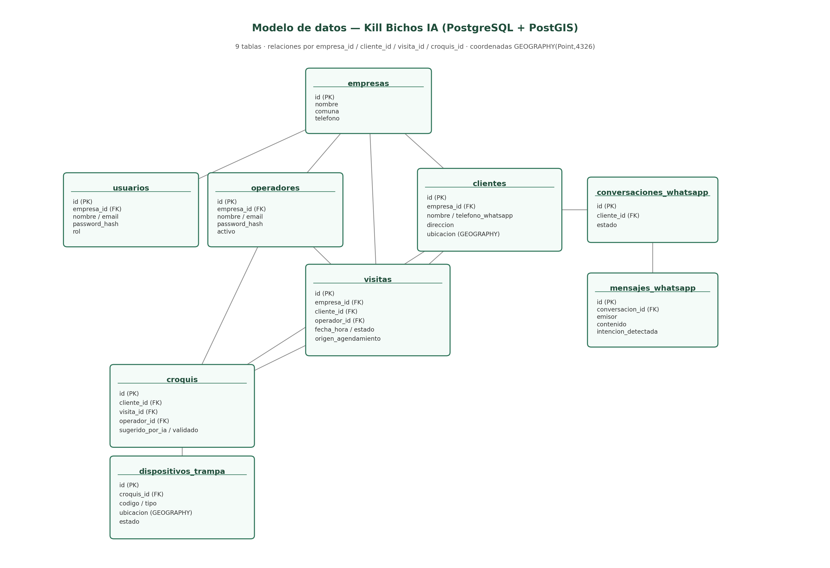
Figure 1. Data model of the Kill Bichos IA project, generated from the real SQL schema.

4.2 FastAPI backend (Swagger / OpenAPI)
Interactive documentation automatically generated by FastAPI (/docs endpoint), with the endpoints grouped by domain: authentication, visits and web panel.
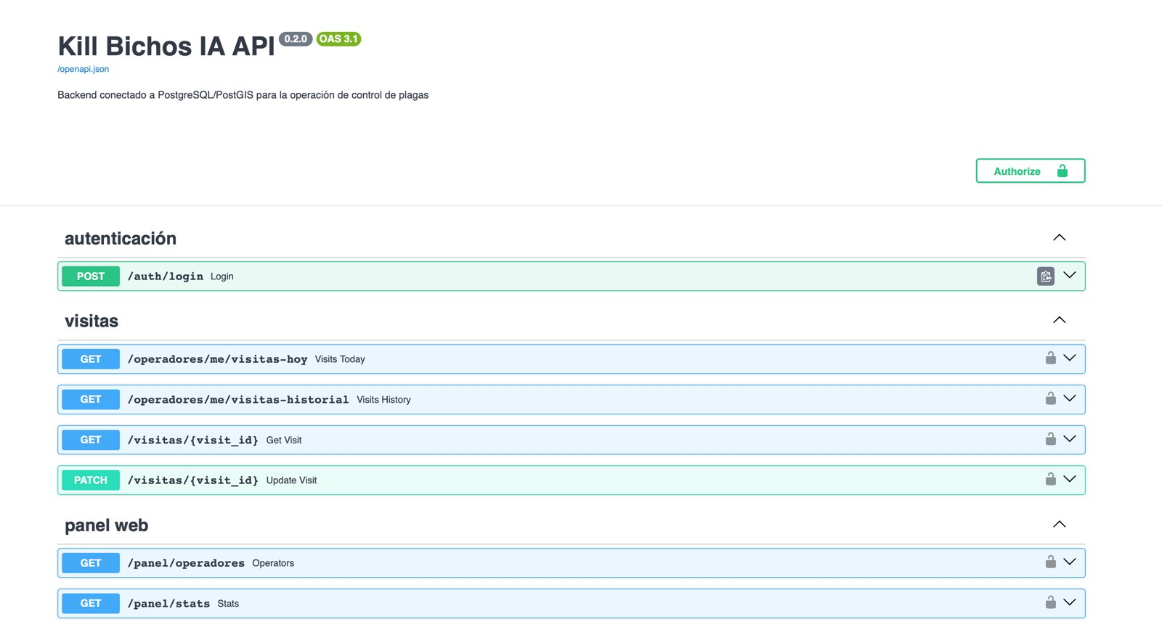
Figure 2. Swagger documentation of the API (Kill Bichos IA API 0.2.0): authentication, visits and web panel.

4.3 Mobile app (Flutter)
Screenshots of the mobile app running on an iPhone, with Kill Bichos's visual identity (yellow/black) and connected to the real backend: login validates against the operadores table in PostgreSQL, and the day's agenda consumes the GET /operadores/me/visitas-hoy endpoint with the JWT token obtained at login. The trap map screenshot shows the list of traps with the Confirm and Remove actions; the Google Maps view was enabled after that screenshot was taken and is not yet included as an image in this report.
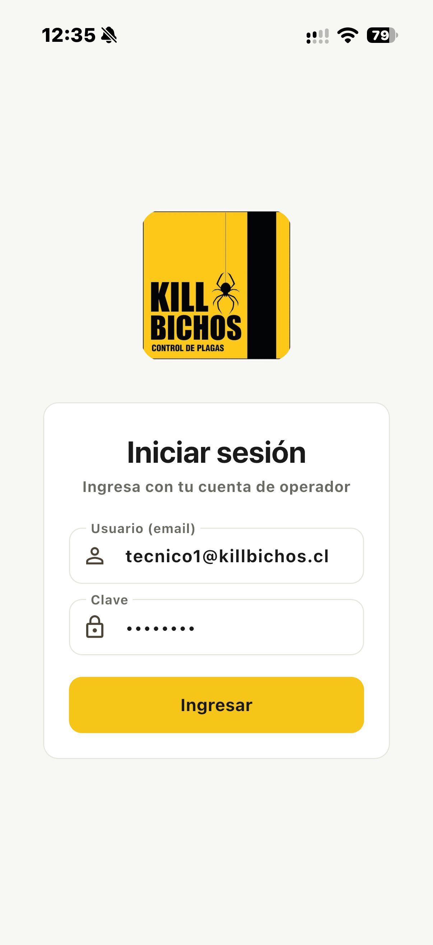 | 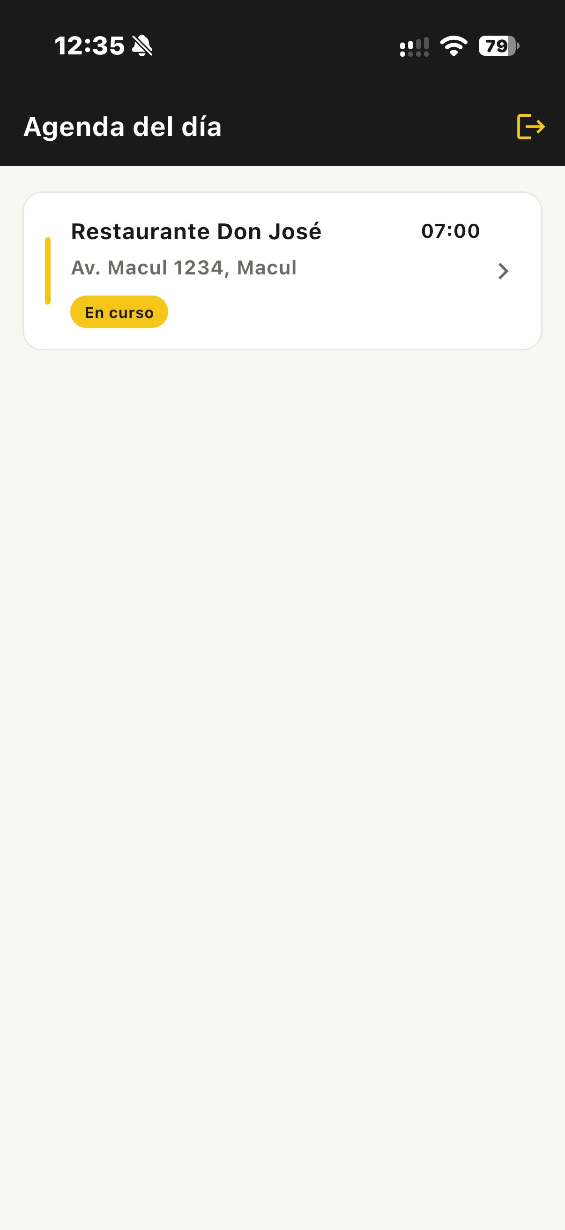 | 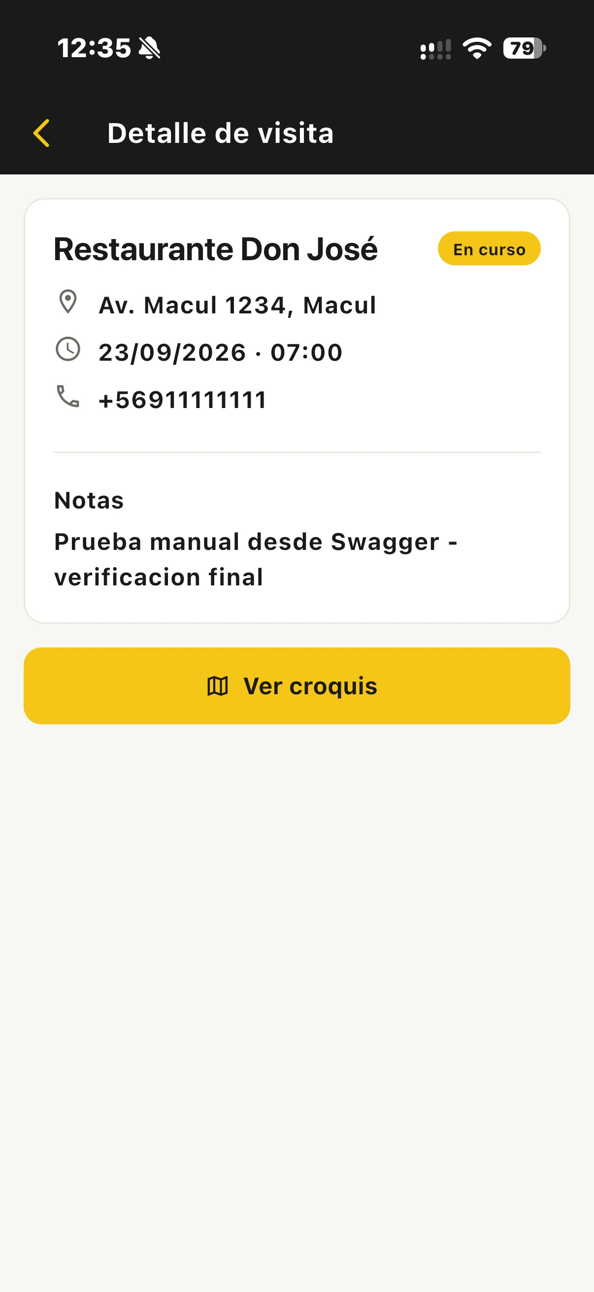 | 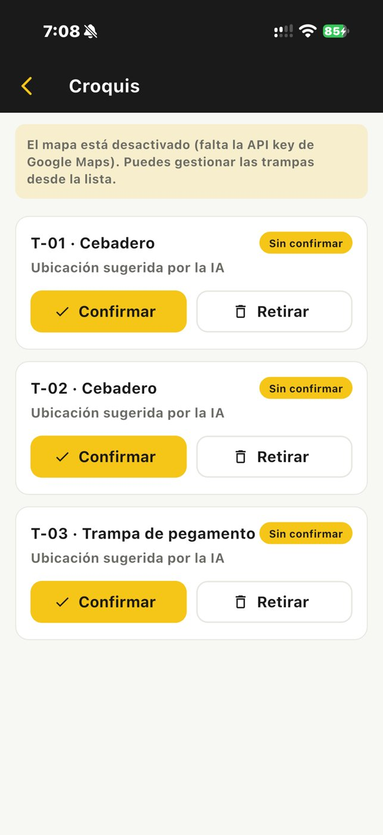
Figure 3. Mobile app: Login. | Figure 4. Mobile app: Day's agenda. | Figure 5. Mobile app: Visit details. | Figure 6. Mobile app: Trap map with traps.

4.4 Web panel (React)
Administrator panel: agenda with indicators, filter by date and technician, and client management with search. The clients named PRUEBA-AUTO were created by the test script and will be deleted before demonstrations.
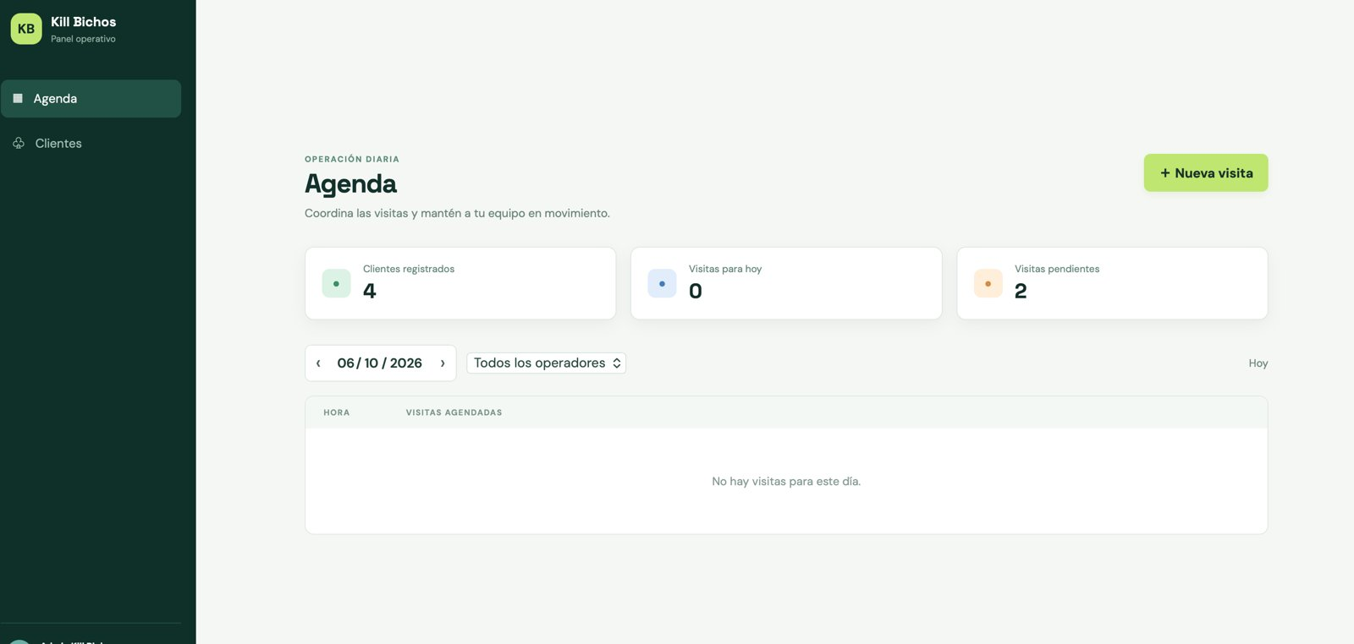
Figure 7. Administrator web panel: agenda with statistics (registered clients, today's visits and pending) and filter by date and operator.
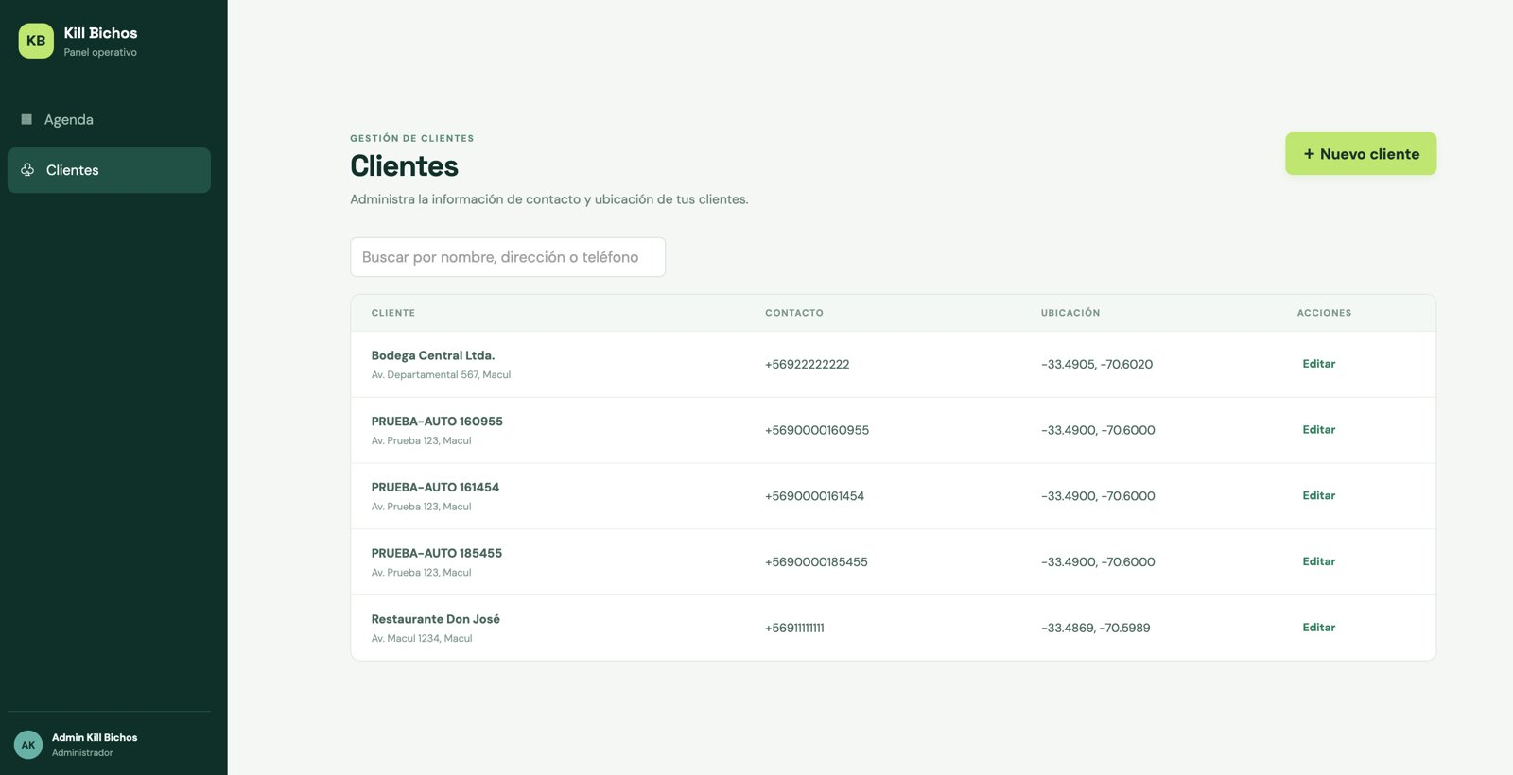
Figure 8. Administrator web panel: client management with search, contact details and location.

4.5 Running database (Docker)
Docker Desktop with the system's three services (database, backend and web panel) running, started with a single command.
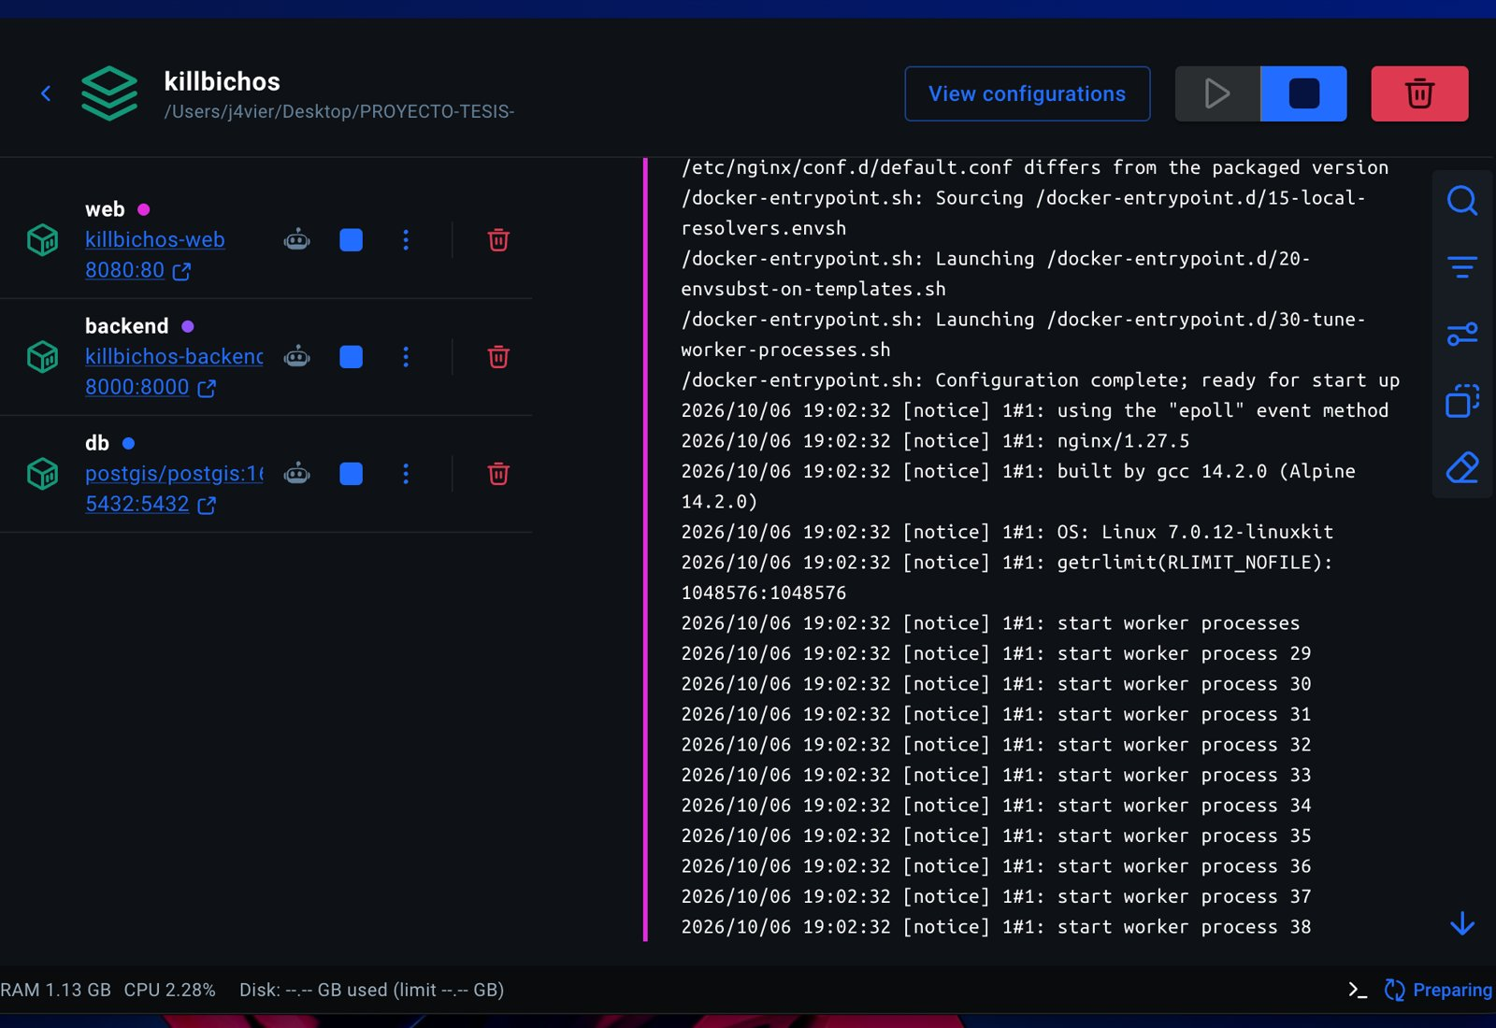
Figure 9. Docker Desktop with the system's three services running (web, backend and database) started with docker compose.

4.6 Test results
Results of the integration test script and of the unit tests. The first run detected 3 failing cases; after the fix, the second run passed all 32 cases.
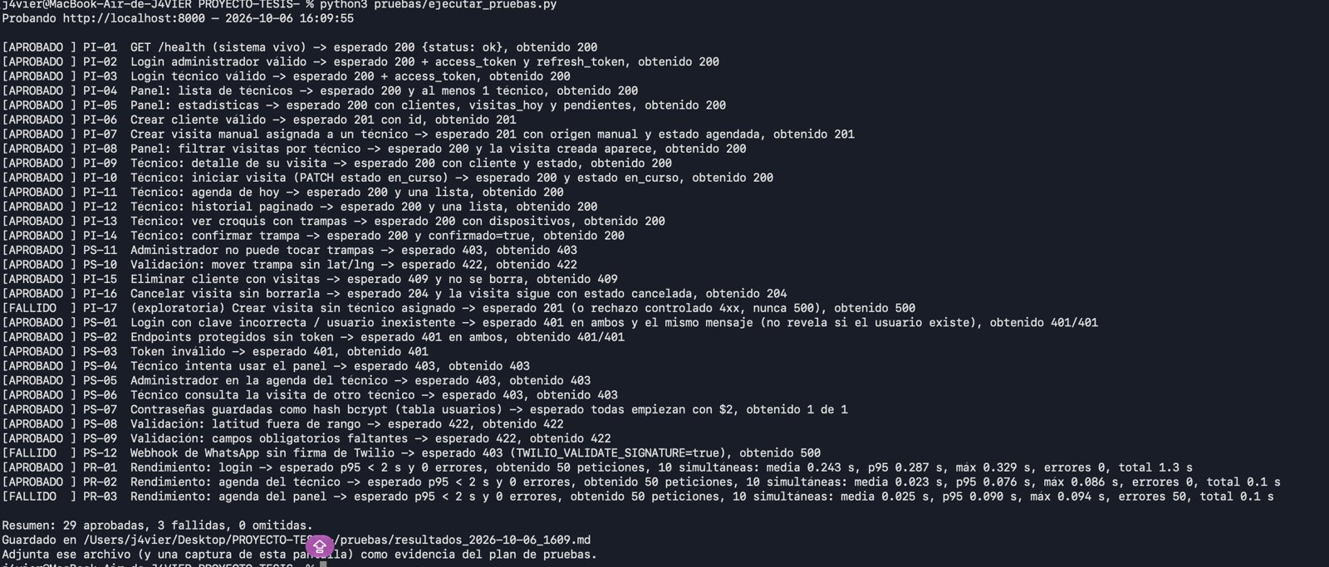
Figure 10. First run of the test script (October 6, 16:09): 29 passed and 3 failed (PI-17, PS-12 and PR-03).
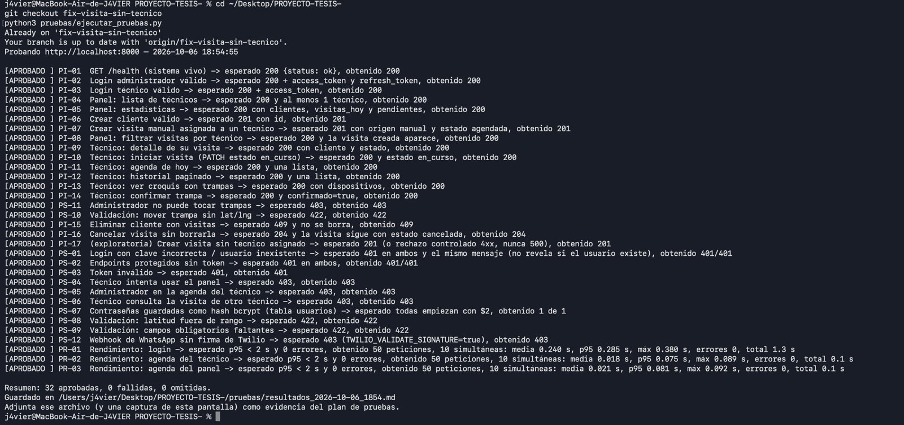
Figure 11. Second run (October 6, 18:54), with the fix applied: 32 passed, 0 failed and 0 skipped.
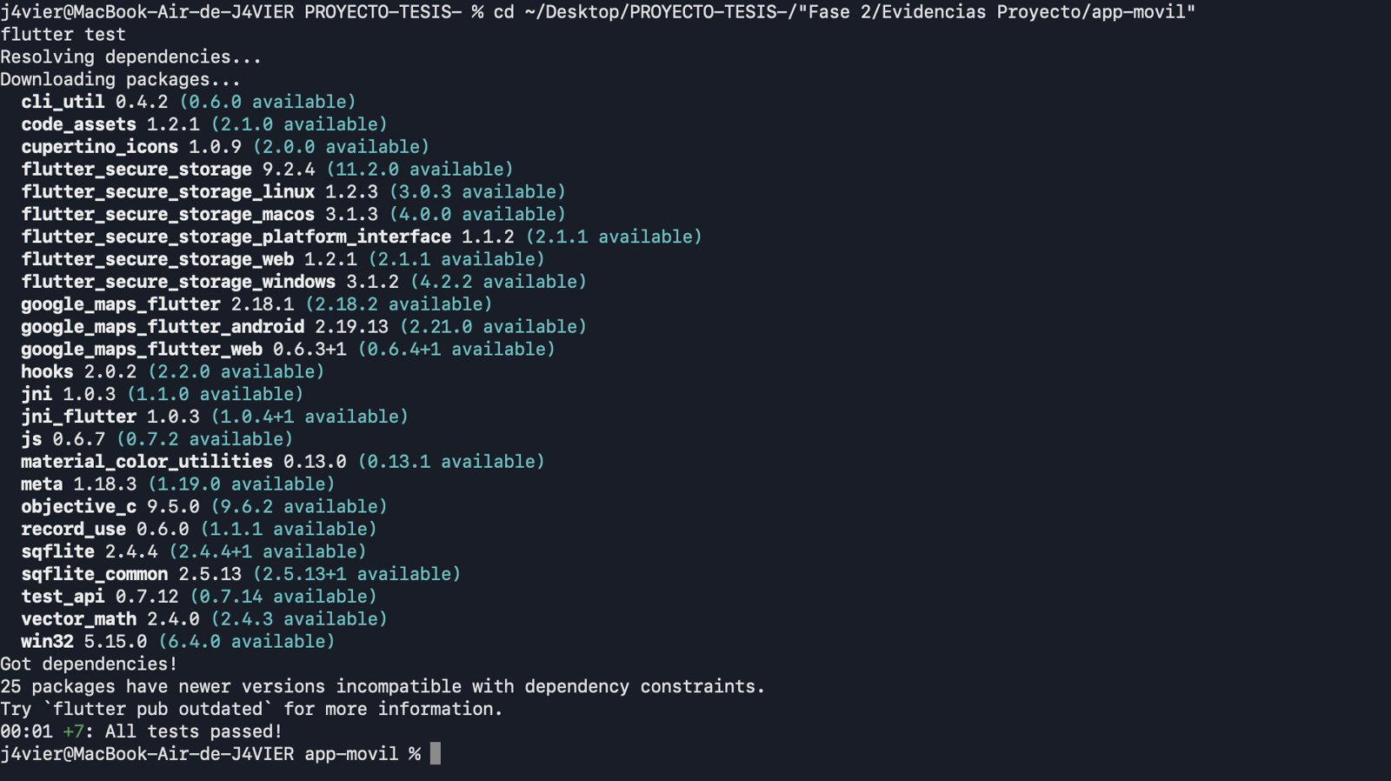
Figure 12. Mobile app tests with flutter test: 7 tests passed.
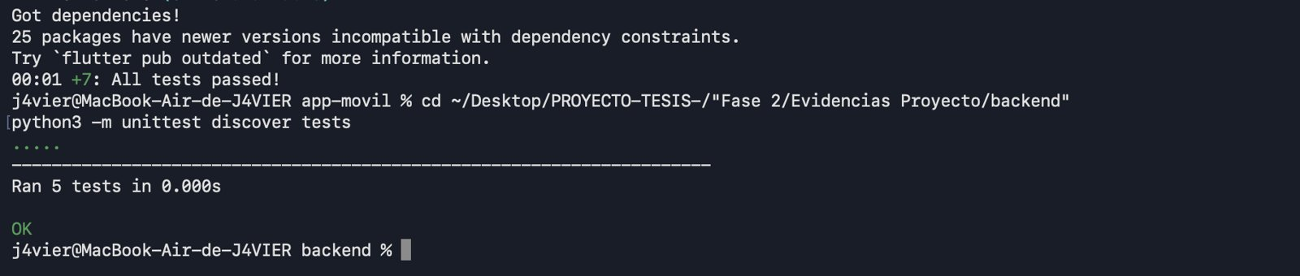
Figure 13. Backend unit tests (python3 -m unittest discover tests): 5 tests, result OK.

4.7 Version control (GitHub)
Repository history with integration through Pull Requests, with no direct commits to main. The merge of PR #1 (backend) and PR #10, which explains the 3 failing tests, their cause and their fix, are shown.
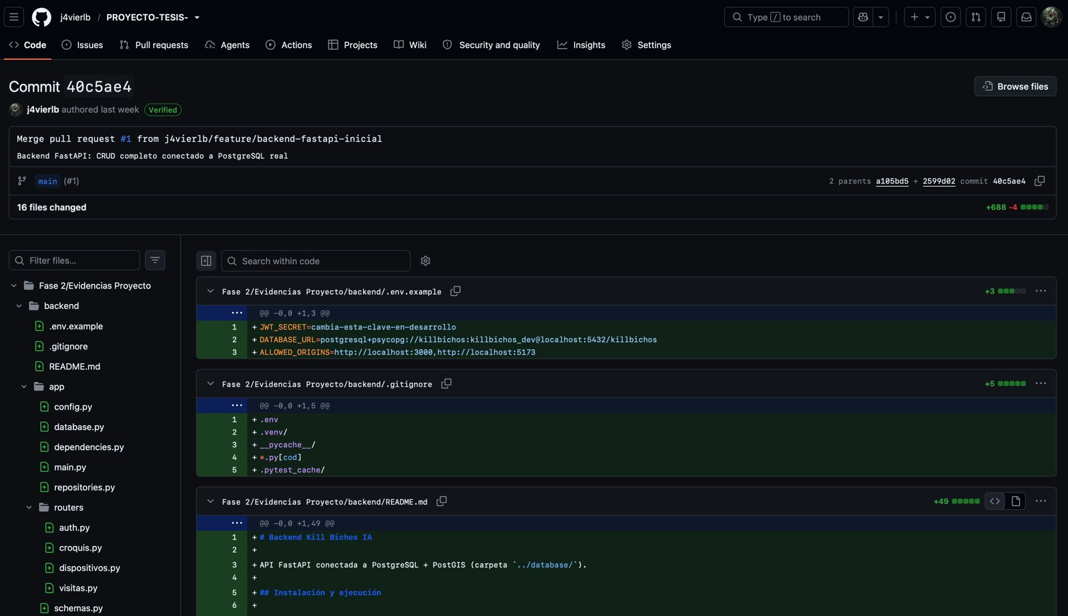
Figure 14. GitHub history: integration through Pull Requests (PR #1, FastAPI backend connected to PostgreSQL).
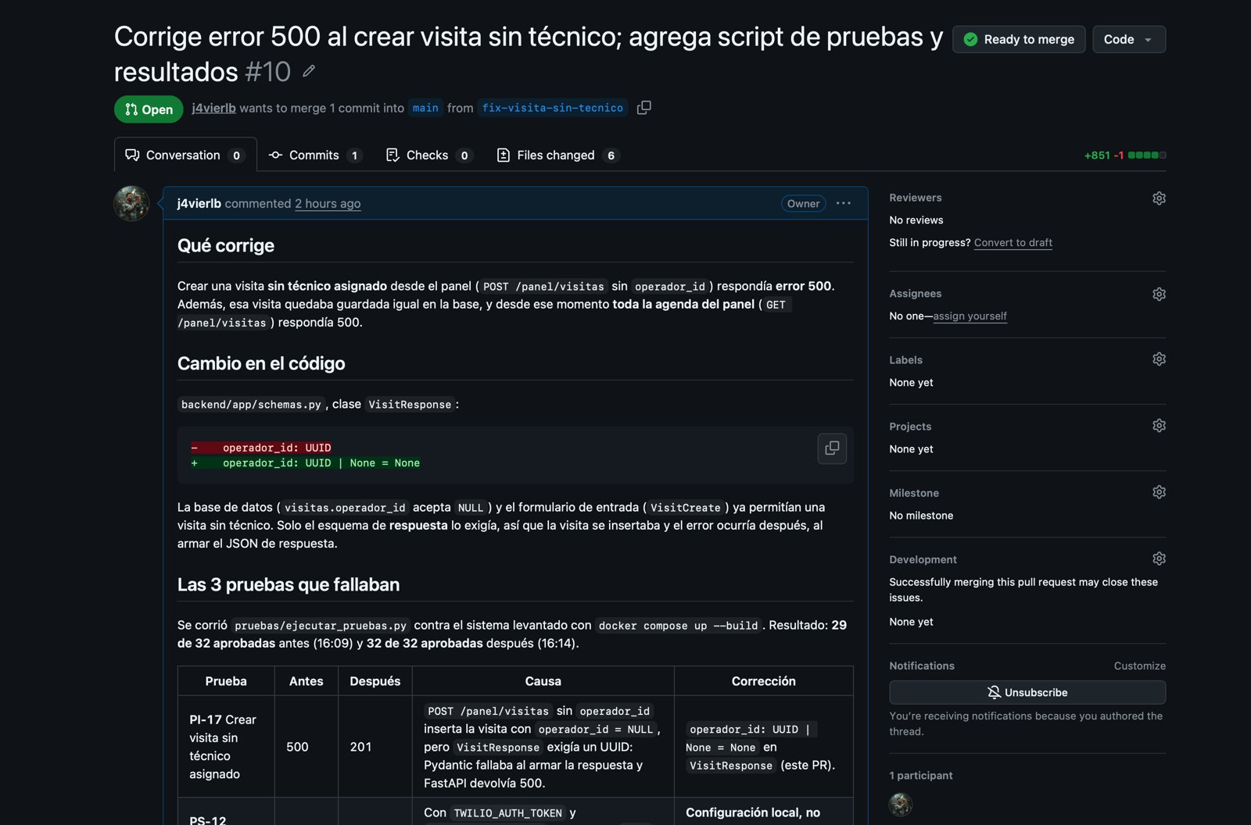
Figure 15. Pull Request #10: fixes the 500 error when creating a visit without a technician and documents the failing tests.

4.8 Repository structure and traceability with Git
The deliverables are organized by phase in the repository:
- Fase 1: group and individual evidence from Phase 1.
- Fase 2/Evidencias Grupales: group guides and evidence (this 2.4 guide).
- Fase 2/Evidencias Individuales: reflection diary 2.1 of each member.
- Fase 2/Evidencias Proyecto: code (backend, frontend, app-movil and database), technical documents (docs), test reports and screenshots (pruebas) and the management documents (Evidencias de documentacion: documents 01 to 10 and the client acceptance form for signature, document 11).
- pruebas/: ejecutar_pruebas.py script and reports of each run, with the date and time in the name.
- Fase 3: folder reserved for the third delivery.
The following table links each Pull Request to the sprint of the plan it corresponds to and to its evidence. It was built from the real Git history; the content of each PR comes from the messages of its commits.
PR | Date | Author | What was done | Plan sprint | Evidence in the repository
#1 | Sep 17 | Javier | FastAPI backend with CRUD connected to real PostgreSQL | S2 Architecture | Evidencias Proyecto/backend and database
#2 | Sep 27 | Javier | Flutter mobile app with the full technician flow; test data scripts; visit history | S2 and S8 | Evidencias Proyecto/app-movil and database
#4 | Sep 29 | Juan | Web panel and scheduling | S3, S4 and S5 | Evidencias Proyecto/frontend
#5 | Sep 29 | Pedro | WhatsApp agent with AI and scheduling validations | S6 Conversation | backend/app/ai and database
#6 | Sep 29 | Javier | Optional coordinates and address for WhatsApp clients | S6 and S8 | backend and app-movil
#7 | Sep 29 | Javier | Chile time to calculate "today"; tzdata package | S10 Quality | backend and database
#8 | Sep 29 | Javier | Full Docker with a single command | S10 / deployment | docker-compose.yml, backend and frontend
#9 | Oct 8 | Juan | Phase 2 documentation and local date in the agenda | S11 and S4 | Evidencias de documentacion
#10 | Oct 8 | Javier | Fixes the 500 error for visits without technician; test script and results | S10 Quality | pruebas/resultados_2026-10-06_*
#11 | Oct 12 | Juan | Dates, clients without coordinates and panel assignment, with tests | S4, S5 and S10 | Evidencias Proyecto/pruebas and frontend
#12 | Oct 17 | Pedro | WhatsApp test plan, AI cost and AI trap map design | S6 and S7 (design) | Evidencias Proyecto/docs
#13 | Oct 19 | Javier | Field trap map: create trap map, add traps by GPS or map, photos; regression 32/32 | S7 and S8 | pruebas/resultados_2026-10-19_2109.md
#14 | Oct 20 | Javier | Security: isolate visits and trap maps by company | S10 Quality | Evidencias Proyecto/backend
#15 | Oct 20 | Javier | Persistent session in the app and POST /auth/refresh endpoint | S8 Mobile | app-movil and backend
#16 | Oct 21 | Juan | Complete panel and trap map viewer with private photos; management documents and evidence | S7, S10 and S11 | frontend, pruebas and Evidencias de documentacion
#17 | Oct 21 | Pedro | AI trap map with satellite photo and button in the app; geocoding; agent schedule adjustment; Twilio Trial bridge | S6, S7 and S8 | backend/app/ai, scripts and docs/evidencias
#18 | Oct 21 | Javier | Regression within business hours, 32 of 32 on Wednesday 23:04 | S10 Quality | pruebas/resultados_2026-10-21_2304.json
#19 | Oct 22 | Javier | Reorganizes Phase 2 according to the delivery structure | S11 Closing | Fase 2/ (folder structure)
#20 | Oct 22 | Pedro | Real WhatsApp test from the phone, 8 of 9 cases (cases 1 to 7 and 9) | S6 Conversation | Evidencias Proyecto/docs (HU-18)

The following table summarizes the status of each plan sprint according to what Git backs up. "No evidence in Git" means that today it cannot be verified with the repository.
Plan sprint | Pull Requests | Evidence | Status
S1 Requirements | — | Phase 1 documents | Done (Phase 1)
S2 Architecture | #1, #2 | Schema and scripts in database; backend | Done
S3 Base panel | #4 | Evidencias Proyecto/frontend | Done
S4 Agenda | #4, #9, #11 | frontend and panel tests | Done
S5 Scheduling | #4, #6, #11 | frontend, backend and tests | Done
S6 Conversation | #5, #6, #12, #17, #20 | Agent in backend; HU-18 and real test from PR #20 | Agent implemented; real test from the phone (8 of 9 cases)
S7 Trap map | #12, #13, #16, #17 | docs/diseno_ia_croquis.md; docs/evidencias/croquis_ia; panel viewer | Manual trap map and viewer done; AI implemented (first version), still to be tested with real addresses
S8 Mobile | #2, #13, #15, #17 | app-movil and regression 32/32 | Done; Android pending (Juan)
S9 Offline | — | No evidence in Git | Not started
S10 Quality | #7, #8, #10, #11, #13, #14, #18 | pruebas/resultados_*.md and panel tests | In progress
S11 Closing | #9, #12, #16, #19 | Evidencias de documentacion (includes the acceptance form for signature) | In progress: signed form and demonstration missing

Detected mismatches and actions. The plan numbers the sprints in sequence, but the work was done in parallel by member: the mobile app (S8) arrived on September 27, before the panel (S3) and the agent (S6), which arrived on the 29th. The management documents were updated on October 20 with the technical evidence; the sheets and retrospectives do not record sprint meetings that did not take place, so they are documented as technical observations. One part of the plan still has no support in Git: offline mode (S9, not started). The AI that suggests traps (S7) now has a first version and one documented case. PR #20 was verified in the Git history. The figure of 156 backend tests comes from the team's report of October 22 and is still to be backed up with its execution report; the repository has 127 backend test functions, and the verified October 20 run records 107 (Fase 2/Evidencias Proyecto/pruebas/resultados_backend_pr14_2026-10-20.json). The screenshots in the appendices are stored in Fase 2/Evidencias Proyecto/capturas_informe_2.4/, with the same name as each figure.

4.9 Google Maps API keys
Google Cloud console (APIs and services, Credentials) with the four keys created on October 22, 2026, one per platform and with restrictions: backend (2 APIs), panel website (HTTP referrer), iOS (iOS apps) and Android (Android apps). The key values are neither shown nor stored in the repository, which is public.
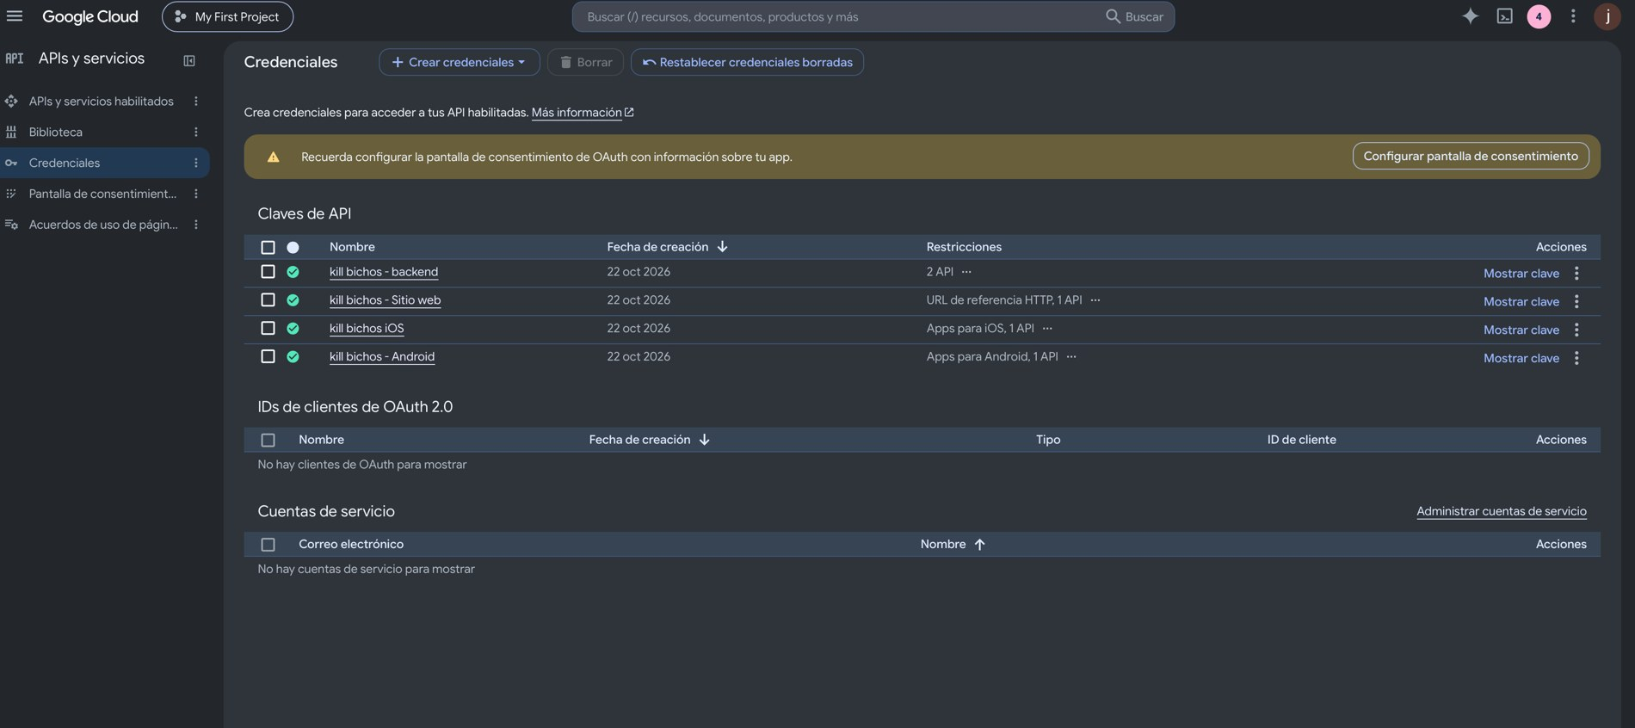
Figure 16. Google Maps API keys created for the backend, the website, iOS and Android.

4.10 Real WhatsApp test from a phone
On October 22, 2026 the agent was tested from a real phone with Twilio's WhatsApp Sandbox, after moving the account to a paid plan; Twilio calls the backend directly, without the Trial account bridge. Of the 9 cases in the plan, 8 passed (1 to 7 and 9). Cases 4 to 7 are shown in the figure and in the table; case 8 (the agent without the OpenAI key) and the screenshots of case 3 (the visit in the panel and in the app) are still pending. Source: docs/HU-18_prueba_whatsapp_real.md.
Case | Message sent | Agent's reply | Verification in the database
4 | I want to schedule for Sunday at 22:00 (Spanish message) | That time is not available; offers 26/10/2026 at 08:00 (Chile time) | No visit created
5 | I want to schedule today at 10:30 (there was a visit at 10:00) (Spanish message) | That time is not available; offers 22/10/2026 at 11:00 | No visit created
6 | Yes, that works for me (Spanish message) | Confirms the visit on 22/10/2026 at 11:00 | Visit scheduled, source whatsapp_ia
7 | I want to cancel my visit (Spanish message) | States that an operator must confirm the change | Intent cancel; visits remain scheduled

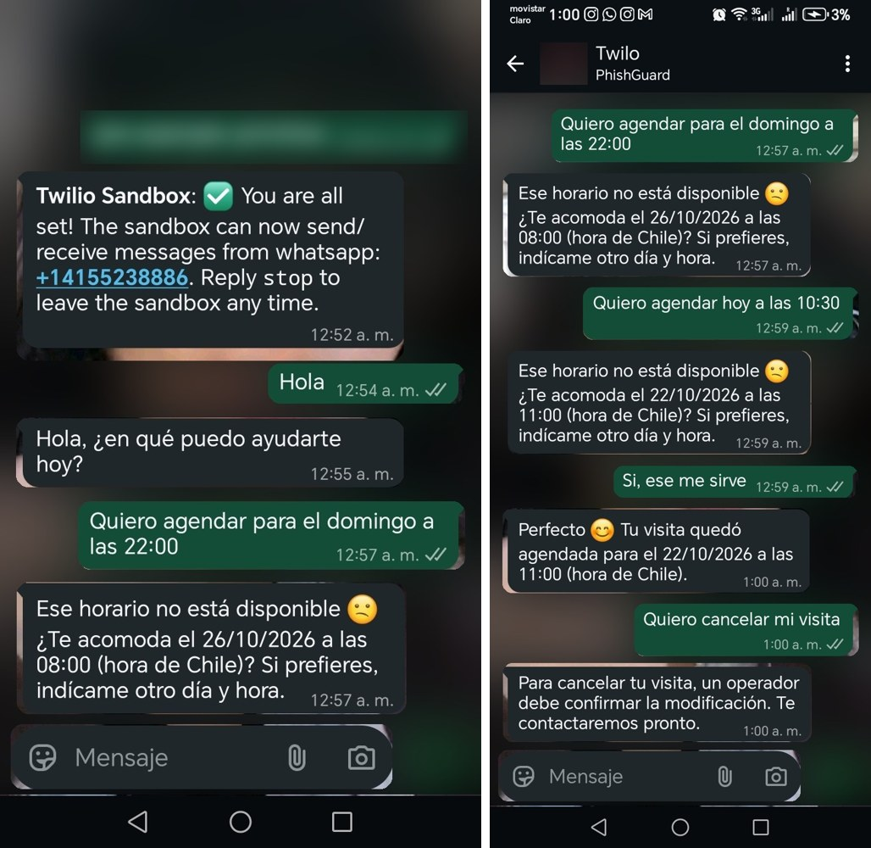
Figure 17. Real WhatsApp test from the phone: joining the Sandbox and cases 4 to 7. The background and the join code were blurred. The conversation is in Spanish, the client's language.

5. Conclusions and reflection

Conclusions
The project meets its technical base: the four parts of the system work together and start with a single command. The most valuable finding of the period was that automated tests catch real errors: a response schema that did not match the database broke the panel agenda, and it was only detected when we ran the integration script. After the fix, all 32 integration cases, the 107 backend tests, the 98 panel tests and the 18 mobile app tests passed.
The most ambitious part of the project, the AI that proposes trap locations for the technician to confirm, now has a first version; it still needs to be tested with real Macul addresses. The real WhatsApp test from the phone has already been carried out (8 of 9 cases, according to the repository record). Still pending are the remaining case and the screenshots, Android testing, the app's offline mode and the validation of the system with the company.

Reflection
Working in short cycles, with one Pull Request per module, let three people integrate their work without overwriting each other. Our iterations were irregular at the beginning, so we decided to fix weekly sprints from now on. We used an AI coding assistant throughout the project: it speeds up the work, but it was only useful when we reviewed what it produced and tested each component with real data. The time zone bug, which showed tomorrow's visits after 9 p.m., is another example of a defect that only appears under specific conditions. We also learned that documentation and evidence must be committed to Git as they are produced, not at the end, so that each member's contribution and each sprint's progress can be verified. In the remaining weeks we will prioritize tests with evidence and validation with real users over adding new features.

6. References
Docker. (n.d.). Docker documentation. https://docs.docker.com
FastAPI. (n.d.). FastAPI documentation. https://fastapi.tiangolo.com
Flutter. (n.d.). Flutter documentation. https://docs.flutter.dev
Google. (n.d.). Google Maps Platform documentation. https://developers.google.com/maps/documentation
OpenAI. (n.d.). OpenAI API documentation. https://platform.openai.com/docs
PostGIS Project Steering Committee. (n.d.). PostGIS documentation. https://postgis.net/documentation
PostgreSQL Global Development Group. (n.d.). PostgreSQL documentation. https://www.postgresql.org/docs
React. (n.d.). React documentation. https://react.dev
Schwaber, K., & Sutherland, J. (2020). The Scrum Guide. https://scrumguides.org
Twilio. (n.d.). Twilio documentation: Messaging for WhatsApp. https://www.twilio.com/docs

